SIMATS ENGINEERING
NAME: A.Preetika Sudhakar
REG NO. 192371073
COURSE NAME: Database Management Systems
COURSE CODE: CSA0501

AIM:
To learn how to use various MySQL loop statements including while, repeat to run a block of code repeatedly based on a condition.

PROGRAM 1 — WHILE LOOP
Document:
Program: Write a function/procedure using WHILE statement to build a string repeatedly until the value of the variable becomes greater than 5 and display the final string.
MySQL Code:
USE house_plotting;
1.WHILE program — build the string until the variable becomes greater than 5.
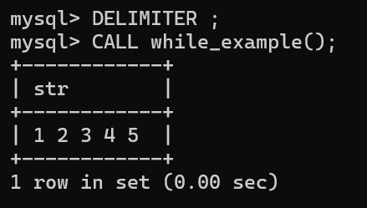
2. REPEAT program — repeat until income >= 4000.
